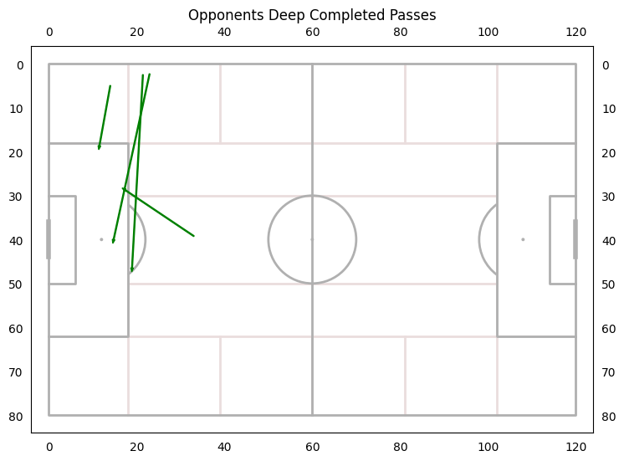

UNLV had only 4 deep completed passes

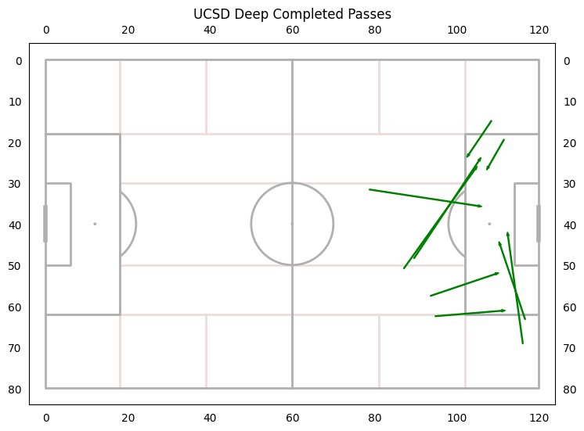

UCSD had 9 deep completed passes

Forward Pass Accuracy: 66%, 1st Half: 67.6%, 2nd Half: 65%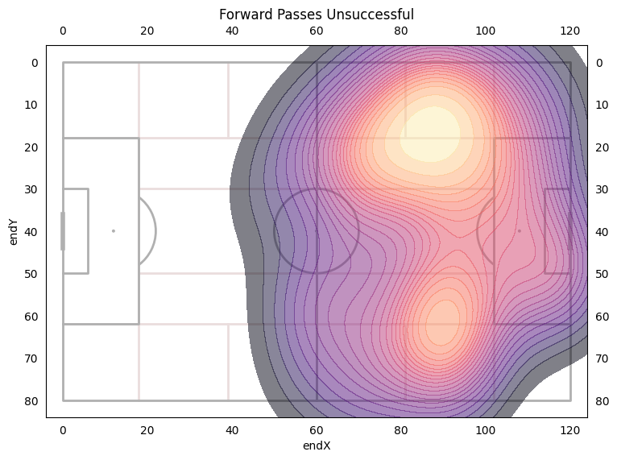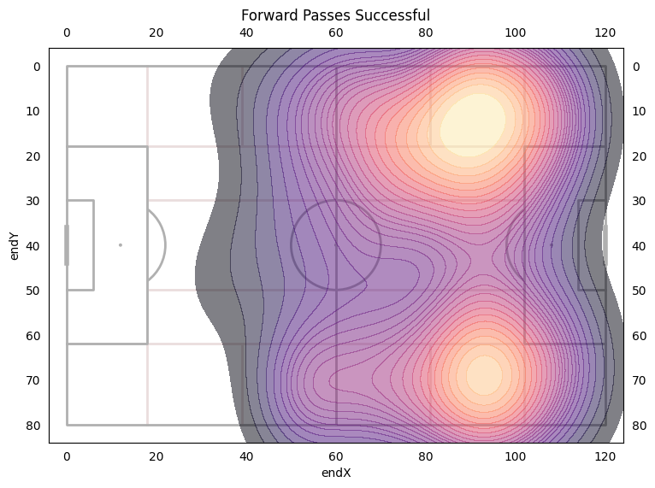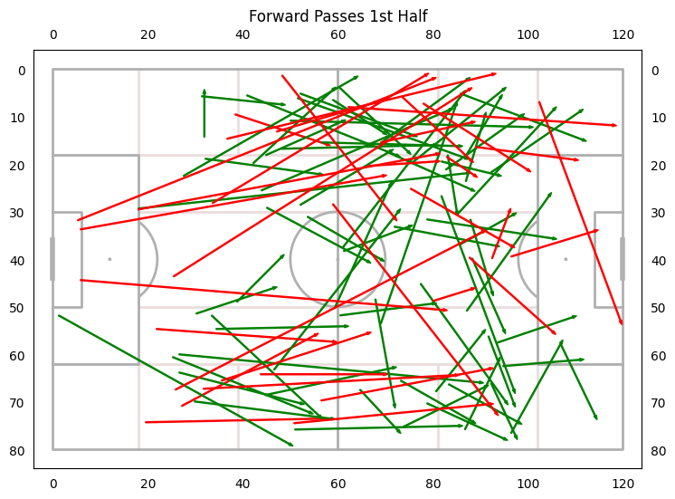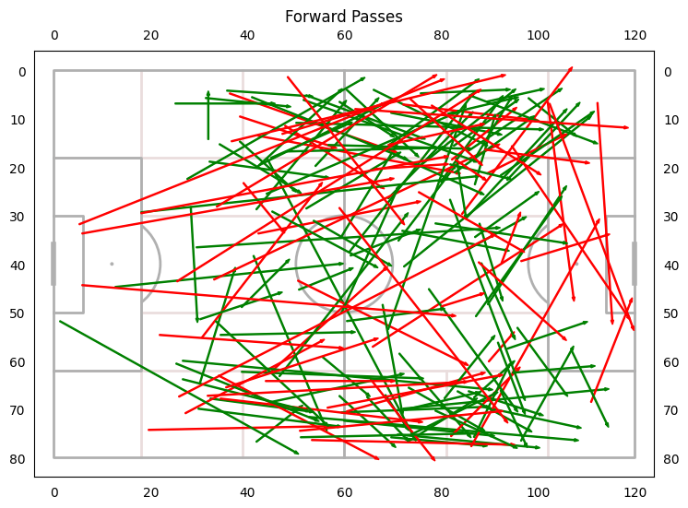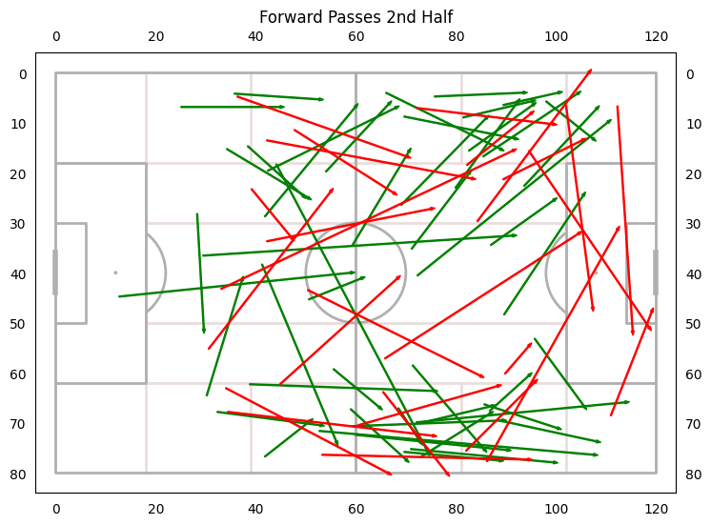

177 Attempted forward passes - increase of 40 from SDSU

27 Accurate Forward pass increase from SDSU

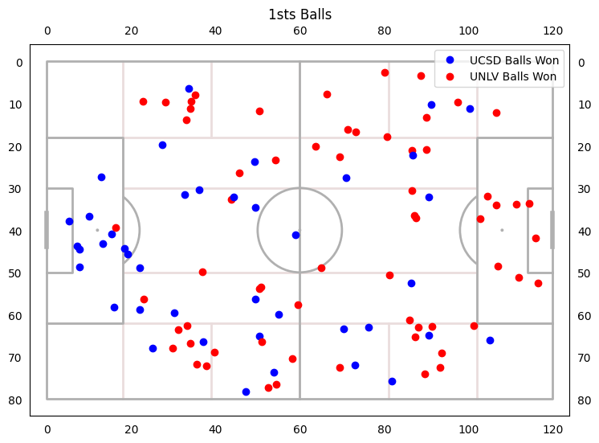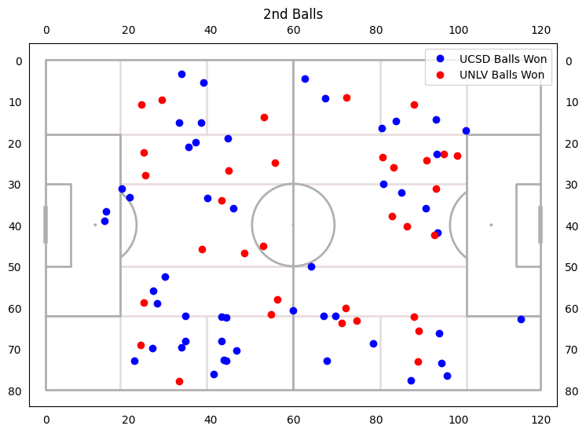

41% 1st Ball Win Rate | 61% 2nd Ball Win Rate

1st Half - 30% 1st Ball Win Rate | 53% 2nd Ball Win Rate

2nd Half -48% 1st Ball Win Rate | 66.6% 2nd Ball Win Rate

The areas where we are not winning first balls are along the wide attacking flanks after we try to play the ball to those flanks in the air. Pairs with forward passes inaccurate to flanks.

If UNLV won the 1st ball UCSD won the second ball 63.2% of the time

If UCSD won the 1st ball UNLV won the second ball 44.8% of the time